File Packer Unpacker Utility

* This project is used to perform packing and unpacking activity for multiple types of files.
* In case of Packing activity me maintain one file which contains metadata and data of multiple files from specified directory.
* In case of Unpacking activity we extract all data from packed files and according to its metadata we create all files.
* In this project we have to use Java as Front end as well as Backend for platform independency.

# Steps to develop above project

* Design one window which accept username and password from user for authentication purpose.



* When user submit the username and password we have to check whether is
* Username: Marvellous
* Password: Marvellous.
* If password or username is incorrect then we have to provide 3 attempts to user. I user is unable to provide correct username and password in 3 attempts we have to close the project.
* For checking whether username and password contains minimum contains 8 letters or not we have to create one thread. That thread also check whether caps lock key is on or not.
* After successful authentication we have to open new window which displays two options as Pack and Unpack.

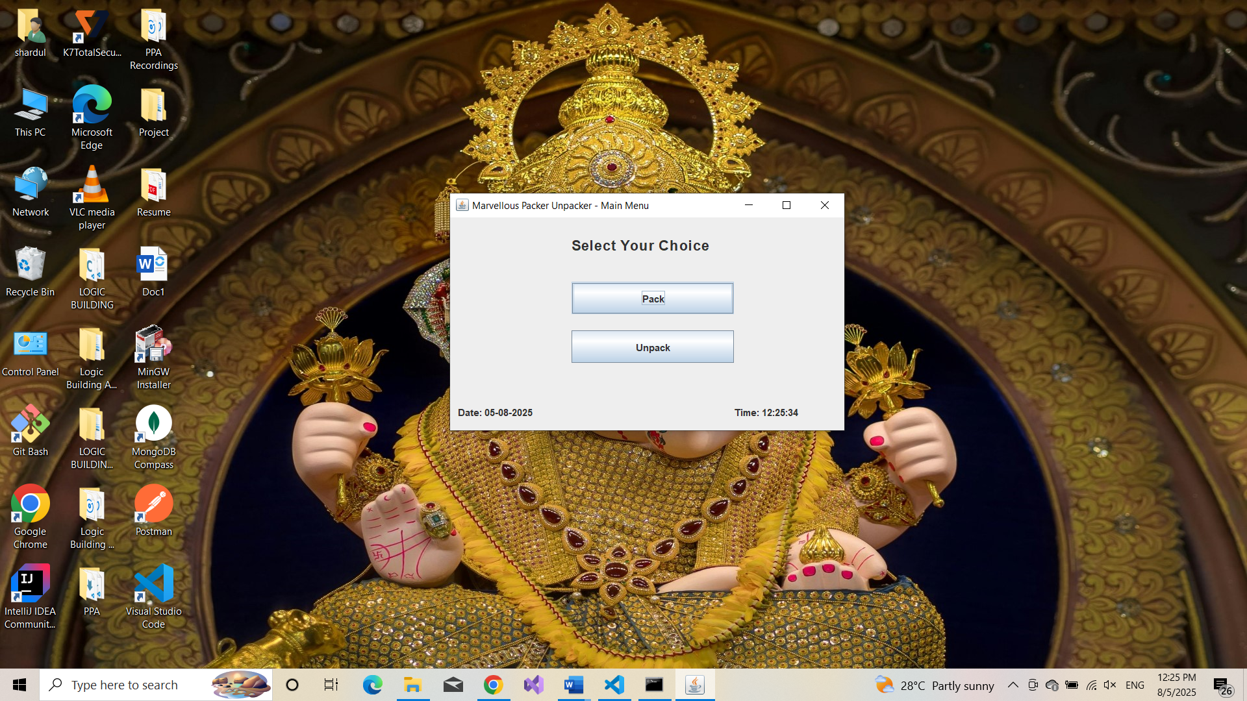

* When user press Pack button we have to open new window which looks like



* From the above window we have to accept name of directory that we want to pack and name of the packed file from user.
* Name of the packed file gets newly created which contains data and metadata of all files from that directory.
* When user click submit button we have to perform “Packing Activity”.
* When user click submit button Message Box Appears As Packing Completed.

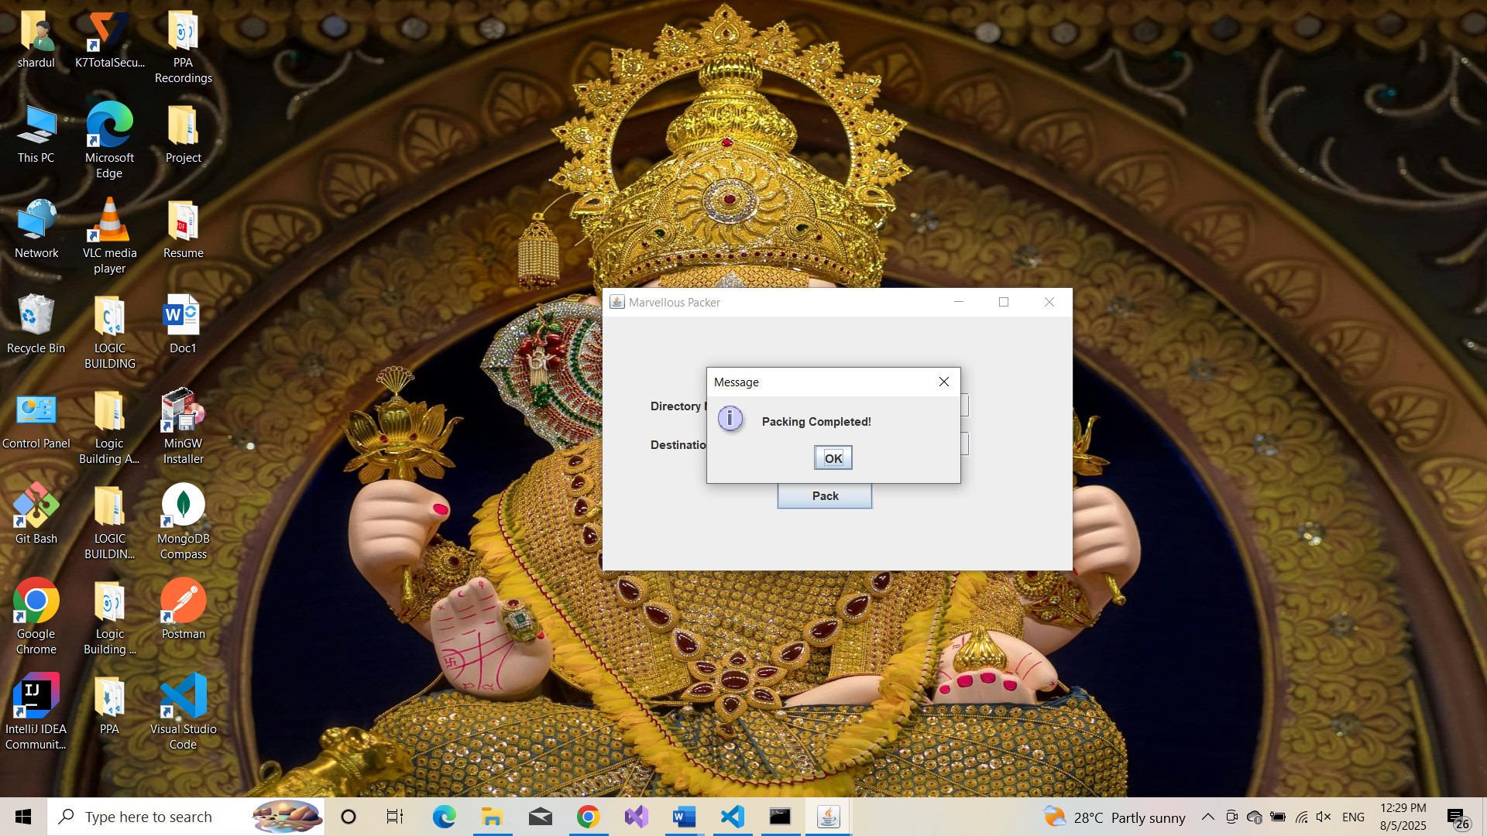

* After that previous window should be displayed as



* When user click Unpack button below window should be displayed as



* From this window accept name of packed file.
* When user click Unpack button we have to perform “Unpacking Activity”.
* When user click Unpack button then Message Box Will Appear As



**Backend Logic**

# Packing Activity :

* In case of Packing activity we accept directory name and file name from user.
* We have to create new regular file as the name specified by the user.
* Now open the directory and traverse each file from that directory. In newly created file write Metadata as header and actual file data in sequence.
* While writing data perform encryption.
* Each name of file ,its size and checksum should be written in log file which gets created in system directory.
* After packing display packing report.

# UnPacking Activity :

* In case of UnPacking activity we accept packed file name from user.
* for authentication of packed file use any logic like Magic Number.
* Open the packed file in read mode and perform below activity as
  + Read header
  + From the name specified in header create new file.
  + Write data into newly created file from packed file.
  + Repeat all above steps till we reached at end of the file unpacked file.
* After unpacking display unpacking report.